GPS NTP/SNTP Time Server
SY-1B-NTP

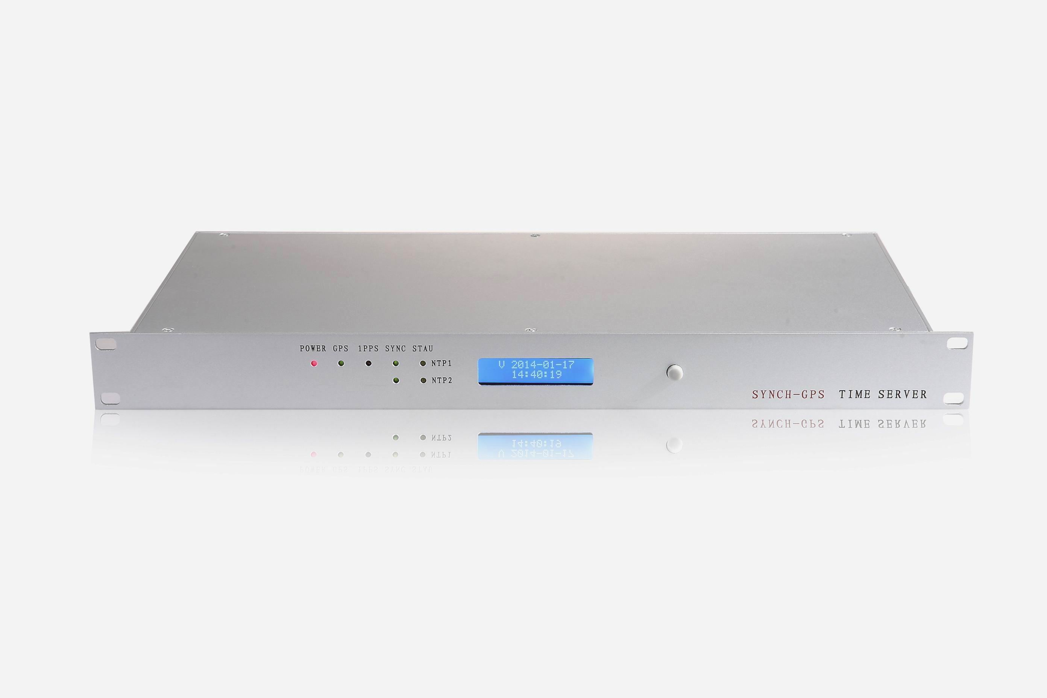

Introduction

The SY-1B-NTP(1 or 2 port of NTP/SNTP output) Network Time server provides a high precision time directly to TCP/IP networks using NTP(Network Time Protocol). It synchronizes time of any NTP clients running on remote PC’ s. It supports both NTP and SNTP clients for more of current popular operating systems including: Microsoft Windows 95/98/Me/NT/2K/XP, Linux, Free BSD, IBM AIX and other UNIX family systems. It can synchronize simultaneously thousands of servers, workstations and routers.

Features

The SY-1B-NTP is high quality professional time server for computing, telecom, military, power grid, traffic systems and other science purposes. It has been manufactured with no mechanical parts as coolers or hard disk. All cooling system has been resolved on natural air circulation outgoing via metal case of unit.

Technology

NTP : supports all versions of NTP, SNTP including latest release 4.1.1 supporting modes: CLIENT,SERVER, BROADCAST, MULTICAST. Authentication: MD5 with manual/automatic key generation.

SNTP : supports all versions of Simple Network Time Protocol

OS Supports :Windows 95/98/Me/2K/XP/WIN7/CE, OS/2, VAX-11/785 v4.3, HPUX, SunOS, Solaris, MIPS Ultrix, ALPHA OSF/1, SGI IRIX, A/UX, AIX, Sinix, BSD, Linux, Dell SVR4, SCO Unixware, CISCO products.

The following time and other output ports are only for options:

IRIG-B: 1 channels of terminal block or more. 2 channels of BNC ports(IRIG-B DC)

RS-485: 1channels(serial code) or more,terminal block port

RS-232:1 channels(block terminal) or more. 1 channel of DB9 connector

PPS: 2 channels 1 PPS(TTL/ active optical isolation and passive) PPM: 1 channel 1PPM

Alarm dry contact output: 1 channel. Support dual redundant power supplies
Other technical Specs:
LAN ： 10/100 Based Tx : RJ-45 connector IEEE 802.3 - shielded data line

Chipset ：Motorola receiver (8) channel with RAIM

Antenna： BNC1.5GHz / 8m + active converter (IP65 to UTP Cat5. cable 200m. (max.500m),

Receiver ：input frequency 1575.42MHz (L1).

Input ：110-240V AC/DC，DC48V,DC24V,DC12V Fuse ：1 electronic

Outputs ：+5V / 5A, +12V / 0.6A, -12V / 0.5A Total Load ：Less than 5 Watt

GPS Accuracy： better than ±100 nsec after synchronization of first 1 hour better than ±1 µsec
during the first hour of operation

NTP Accuracy ：Better than 10 msec (with nanosecond kernel)

Housing ：Metal desktop case,1U

Front Panel：43mm high / 483mm wide

Protection ：rating IP20

LCD Display：6 character+8 character .Can display local date & time ,longitude, latitude,altitude,time zone code,satellite number locked.

Temperature : -20~ 75℃. Ambient temperature supported. Storage: -40~ 125℃
Humidity: 85% max

Housing Color: Grey

GPS Antenna Cable: 30 meters wire with GPS antenna

Warranty: 5 Years

